COMPUTER ARCHITECTURE
CSA1203 ASSESSMENT

NAME: DHEVAGOPALAN B
REG NO: 192512134

Design and Analysis of an Energy-Efficient Pipelined Processor with Hierarchical Memory System for Smart Industrial Monitoring

PARTICULAR | DETAILS
DEPARTMENT | ECE
PROGRAMME | B. Tech
COURSE CODE AND COURSE NAME | CSA 1203 AND COMPUTER ARCHITECTURE
ACADEMIC YEAR/ BATCH | 2 ND YEAR 2025
FACULTY NAME | Mrs K KAVIYA
ASSIGNMENT TITLE | DESIGN AND ANALYSIS OF AN ENERGY-EFFICIENT PIPELINED PROCESSOR WITH HIERARCHICAL MEMORY SYSTEM FOR SMART INDUSTRIAL MONITORING
DATE OF ISSUE | 1.9.26
DATE OF SUBMIUSSION | 2.9.26
MAX MARKS | 100
COURSE OUTCOME(S)-CO | CO1: Analyze the functional units of a computer system including CPU, memory, bus structures, and I/O components by examining instruction execution cycles, addressing modes, and performance metrics such as CPI, clock cycles, and benchmarking.  CO3: Design processor organization by constructing pipelined datapath structures, identifying hazard types (data, control, structural), and comparing superscalar techniques such as out-of-order execution, speculative execution, and simultaneous multithreading (SMT).  CO4: Implement hierarchical memory systems by differentiating cache levels (L1, L2, L3), virtual memory with paging, and advanced memory technologies (DRAM, SRAM, NAND Flash, MRAM, RRAM) based on latency, bandwidth, and throughput characteristics.
BLOOM”S TAXANOMY LEVEL | L3 – Apply; L4 – Analyze
SDG MAPPING | SDG 7 – Affordable and Clean Energy  SDG 9 – Industry, Innovation and Infrastructure  SDG 12 – Responsible Consumption and Production
INDUSTRY/ SOCIAL RELEVENCE | Smart Industrial Automation, IoT Monitoring, Predictive Maintenance, Energy-Efficient Computing and Industrial Safety.

- PROBLEM UNDERSTANDING AND FORMULATION

Smart industrial monitoring systems continuously collect data from sensors such as temperature, pressure, vibration, humidity, current, and gas sensors. Processing this large amount of sensor data requires a processor that can perform computations quickly while consuming minimal energy. Conventional processor architectures may consume significant power because of frequent memory accesses and inefficient instruction execution.
The proposed project focuses on designing an energy-efficient pipelined processor integrated with a hierarchical memory system for smart industrial monitoring applications. The main problem is to achieve a suitable balance between processing speed, power consumption, memory access time, and hardware complexity.
The processor uses pipelining to improve instruction throughput by dividing instruction execution into multiple stages. A hierarchical memory system consisting of registers, cache memory, and main memory is used to reduce the average memory access time and unnecessary data transfers.
The major objectives are:
- To design a pipelined processor suitable for real-time industrial monitoring.
- To reduce processor power consumption through efficient instruction execution and memory access.
- To improve performance using instruction pipelining.
- To implement a hierarchical memory organization to reduce memory access latency.
- To evaluate processor performance using parameters such as execution time, throughput, power consumption, and memory hit rate.
- To analyze the trade-off between performance, power, area, and design complexity.
The basic performance objective can be expressed as:
Performance ∝ Instruction Throughput / Execution Time
while energy efficiency can be evaluated using:
Energy Efficiency = Useful Computation / Energy Consumed
Therefore, the proposed architecture aims to achieve higher throughput with lower energy consumption without compromising the reliability required for industrial monitoring.

- APPLICATION OF COURSE FOR DOMAIN KNOWLEDGE

The project applies concepts from Computer Architecture, Digital Logic Design, Embedded Systems, VLSI Design, and Operating/Memory Systems.
Processor Architecture
Pipelining is used to divide instruction execution into stages such as:
- Instruction Fetch (IF)
- Instruction Decode (ID)
- Execute (EX)
- Memory Access (MEM)
- Write Back (WB)
Multiple instructions can be processed simultaneously in different pipeline stages, increasing instruction throughput.
Memory Organization
A hierarchical memory system is implemented using different levels of memory:
Processor → Registers → Cache → Main Memory
Registers provide the fastest access, followed by cache memory and then main memory. Frequently used sensor-processing data can remain in the cache, reducing costly main-memory accesses.
Power-Efficient Architecture
Energy consumption can be reduced by minimizing unnecessary switching activity, reducing memory accesses, and using techniques such as clock gating or selective activation of processor units.
Industrial Monitoring Application
The processor can process sensor information and perform operations such as:
- Sensor-data filtering
- Threshold comparison
- Fault detection
- Temperature monitoring
- Vibration analysis
- Equipment-status monitoring
- Alarm generation
- Basic predictive-maintenance calculations
For example, if a vibration sensor produces values continuously, the processor can compare each value against a predefined threshold. If the value exceeds the threshold, the system can generate a warning signal

System Architecture / Design
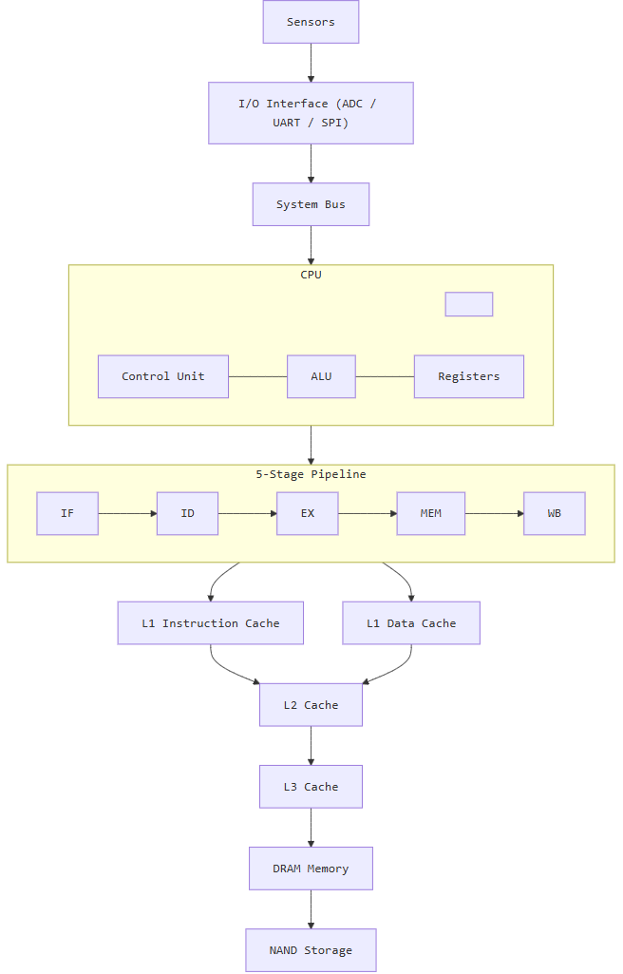

Calculations of
- CPI
- Clock cycles
- Execution time
- Speedup
- Cache hit/miss rate
- AMAT

1. CPI (Cycles Per Instruction)
Formula
$$CPI=\frac{Total Clock Cycles}{Total Instructions Executed}$$
Assume the optimized processor executes 1,000,000 instructions in 1,200,000 clock cycles.
$$CPI=\frac{1,200,000}{1,000,000} \\ \boxed{CPI=1.2}$$
Comparison
Processor Design | CPI
Non-Pipelined Processor | 4.5
Basic Pipelined Processor | 1.8
Optimized Pipelined Processor | 1.2
Result
The optimized pipelined processor has the lowest CPI of 1.2, indicating better instruction throughput.

2. Clock Cycle Time
Formula
$$Clock Cycle Time=\frac{1}{Clock Frequency}$$
Given:
$$Clock Frequency=1GHz \\ Clock Cycle Time=\frac{1}{1×{10}^{9}} \\ \boxed{Clock Cycle Time=1ns}$$
Result
Each processor clock cycle takes 1 nanosecond.

3. Total Clock Cycles
Formula
$$Total Clock Cycles=Instruction Count×CPI$$
Non-Pipelined Processor
$$=1,000,000×4.5 \\ \boxed{4,500,000 cycles}$$
Basic Pipeline
$$=1,000,000×1.8 \\ \boxed{1,800,000 cycles}$$
Optimized Pipeline
$$=1,000,000×1.2 \\ \boxed{1,200,000 cycles}$$
Comparison
Architecture | Instruction Count | CPI | Total Clock Cycles
Non-Pipelined | 1,000,000 | 4.5 | 4,500,000
Basic Pipeline | 1,000,000 | 1.8 | 1,800,000
Optimized Pipeline | 1,000,000 | 1.2 | 1,200,000

4. CPU Execution Time
Formula
$$CPU Execution Time=Total Clock Cycles×Clock Cycle Time$$
Alternatively:
$$CPU Execution Time=Instruction Count×CPI×Clock Cycle Time$$
A. Non-Pipelined Processor
$$=1,000,000×4.5×1ns \\ =4,500,000ns \\ \boxed{4.5ms}$$

B. Basic Pipelined Processor
$$=1,000,000×1.8×1ns \\ \boxed{1.8ms}$$

C. Optimized Pipelined Processor
$$=1,000,000×1.2×1ns \\ \boxed{1.2ms}$$
Final Comparison
Processor | Execution Time
Non-Pipelined | 4.5 ms
Basic Pipeline | 1.8 ms
Optimized Pipeline | 1.2 ms
Result
The optimized pipelined processor completes the same workload in the shortest time.

5. Speedup Calculation
Formula
$$Speedup=\frac{Execution Time of Old System}{Execution Time of New System}$$
Comparing non-pipelined and optimized pipelined processors:
$$Speedup=\frac{4.5}{1.2} \\ \boxed{Speedup=3.75}$$
Result
$$\boxed{The optimized pipeline is 3.75× faster}$$
than the non-pipelined processor.

6. Cache Hit Rate and Miss Rate
Given:
- Total Memory Accesses = 10,000
- Cache Hits = 9,500
- Cache Misses = 500
Cache Hit Rate
Formula
$$Hit Rate=\frac{Cache Hits}{Total Memory Accesses}×100 \\ =\frac{9500}{10000}×100 \\ \boxed{Hit Rate=95\%}$$

Cache Miss Rate
Formula
$$Miss Rate=\frac{Cache Misses}{Total Memory Accesses}×100 \\ =\frac{500}{10000}×100 \\ \boxed{Miss Rate=5\%}$$

Result
Parameter | Value
Total Accesses | 10,000
Cache Hits | 9,500
Cache Misses | 500
Hit Rate | 95%
Miss Rate | 5%
A high cache hit rate reduces expensive accesses to lower memory levels.

7. AMAT (Average Memory Access Time)
For a hierarchical memory system:
Formula
$$AMAT=L1 Hit Time+L1 Miss Rate×Miss Penalty$$
First calculate the L1 miss penalty.
L1 Miss Penalty
$$L1 Miss Penalty=L2 Access Time+L2 Miss Rate×Main Memory Access Time$$
Substitute:
$$=5+\left(0.10×100\right) \\ =5+10 \\ \boxed{L1 Miss Penalty=15ns}$$
Calculate AMAT
Given:
- L1 Hit Time = 1 ns
- L1 Miss Rate = 5% = 0.05
- L1 Miss Penalty = 15 ns
$$AMAT=1+\left(0.05×15\right) \\ =1+0.75$$

GRAPH COMPARISON

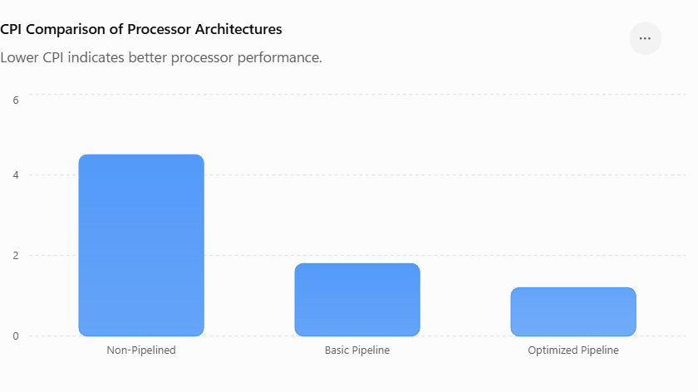
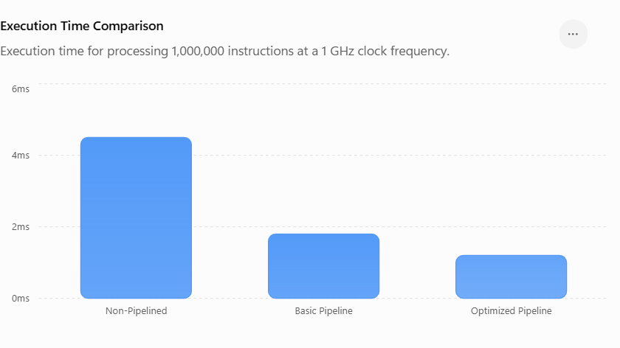

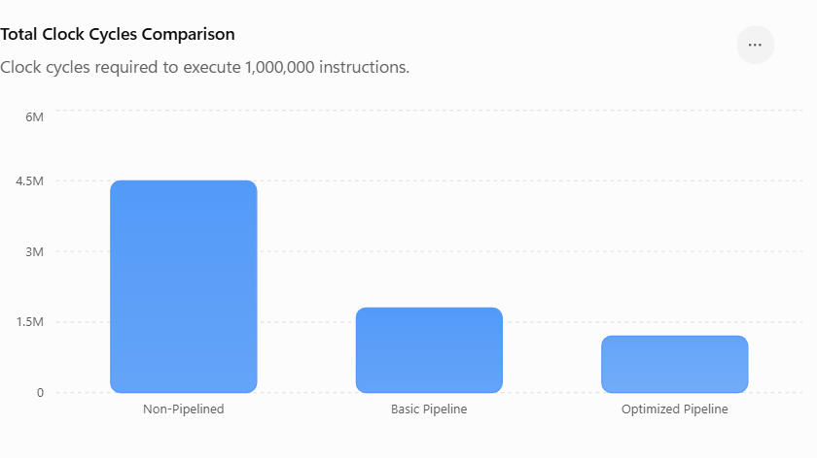
ROUGH GRAPH

CPI Comparison
CPI
4.5 ████████████████████ Non-Pipeline
1.8 ████████ Basic Pipeline
1.2 █████ Forwarding Pipeline

Graph 2: Execution Time Comparison
4.5ms ████████████████████ Non-Pipeline
1.8ms ████████ Basic Pipeline
1.2ms █████ Optimized Pipeline

Performance Comparison & Engineering Recommendation

Different processor organizations are compared based on performance, power consumption, and hardware complexity.
Pipelining with forwarding and hazard detection provides improved throughput with moderate complexity.
Complex out-of-order and speculative techniques are avoided where their additional power is not justified.
The proposed cache hierarchy reduces memory access latency and improves overall system performance.
Therefore, the optimized pipelined architecture is recommended for energy-efficient industrial monitoring.
SIMULATION

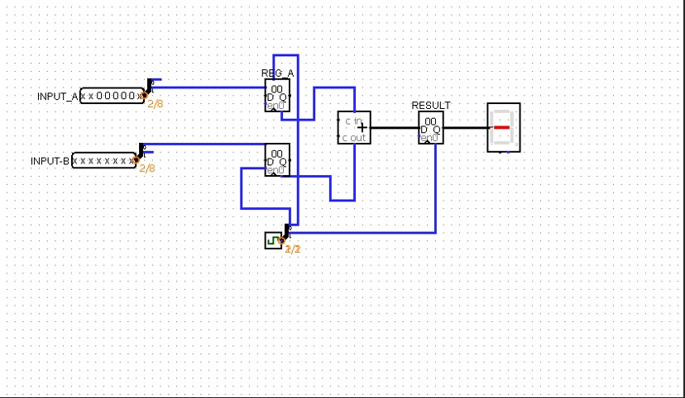
SOLUTION METHODOLOGY – DESIGN / IMPLEMENTATION

The proposed system consists of four major components:
Sensor Input → Processor → Hierarchical Memory → Monitoring/Alert Output
The processor architecture is designed using a multi-stage pipeline.
Pipeline Design
The proposed five-stage pipeline operates as follows:
Stage | Function
IF | Fetches instruction from instruction memory
ID | Decodes instruction and reads registers
EX | Performs arithmetic/logical operations
MEM | Performs data memory read/write
WB | Writes results back to registers
Pipeline registers are placed between stages to temporarily store intermediate results.
Hierarchical Memory Design
The memory subsystem contains:
  - Register File: Stores frequently accessed operands and intermediate values.
  - L1 Cache: Stores recently/frequently accessed instructions and sensor data.
  - Main Memory: Stores larger amounts of program and sensor-processing data.
When the processor requests data, it first checks the cache. If the required data is found, a cache hit occurs. Otherwise, a cache miss causes the system to access the next memory level.
1 The average memory access time can be represented conceptually as:
AMAT = Hit Time + Miss Rate × Miss Penalty
2 Reducing the cache miss rate can therefore improve processor performance and reduce unnecessary energy consumption.
3 Overall Implementation Flow
  - Industrial sensor data is generated or supplied as input.
  - The processor fetches the required instructions.
  - Instructions move through the pipeline stages.
  - Sensor data is stored/accessed through the memory hierarchy.
  - Arithmetic and logical operations are performed.
  - Results are compared with predefined monitoring thresholds.
  - The system generates normal-status or warning-status outputs.
  - Processor performance and energy-related parameters are recorded for analysis.

4. USE OF APPROPRIATE MODERN TOOLS / TECHNIQUES
Modern hardware-design and simulation tools can be used to design and validate the proposed processor.
Hardware Description Language
Verilog or SystemVerilog can be used to describe the processor datapath, control unit, pipeline registers, register file, ALU, cache, and memory components.
Simulation
A digital simulation environment can be used to verify:
  - Instruction execution
  - Pipeline operation
  - Register transfers
  - ALU functionality
  - Memory read/write operations
  - Cache hit and miss behavior
  - Hazard handling
  - Reset functionality
FPGA-Based Implementation
The processor can be synthesized and implemented on an FPGA platform to demonstrate its practical operation. FPGA implementation provides information about resource utilization, maximum operating frequency, and timing behavior.
Power Analysis
Power-analysis techniques can be used to estimate dynamic and static power consumption. Switching activity in the processor can be analyzed to identify components responsible for higher energy consumption.
Modern Optimization Techniques
The following techniques can be incorporated:
  - Clock gating
  - Operand isolation
  - Cache optimization
  - Reduced memory access
  - Pipeline optimization
  - Low-power instruction execution
  - Efficient data-path design
These techniques help improve the energy efficiency of the processor while maintaining acceptable performance.

5. RESULT, TESTING AND VALIDATION
The designed processor must be tested using different instruction sequences and industrial monitoring scenarios.
Functional Testing
Individual processor modules are tested first. The ALU is tested using arithmetic and logical operations, while the register file is tested for read/write operations. Memory modules are tested using different addresses and data patterns.
Pipeline Testing
The processor is tested with consecutive instructions to verify that instructions correctly move through all pipeline stages. Special attention is given to pipeline hazards.
Three major hazards are considered:
  - Data Hazard: Occurs when one instruction depends on the result of an earlier instruction.
  - Control Hazard: Occurs due to branch or jump instructions.
  - Structural Hazard: Occurs when multiple instructions require the same hardware resource.
Forwarding, stalling, and appropriate control logic can be used to resolve these hazards.
Memory Testing
Cache performance is evaluated using:
  - Cache hit rate
  - Cache miss rate
  - Memory access latency
  - Number of main-memory accesses
Performance Evaluation
The following parameters can be measured:
Parameter | Purpose
Execution time | Measures processing speed
Throughput | Measures instructions processed per unit time
Clock frequency | Determines operating speed
Cache hit rate | Evaluates memory efficiency
Power consumption | Measures energy usage
Energy per operation | Evaluates energy efficiency

The proposed architecture can then be compared with a non-pipelined or non-hierarchical baseline architecture.
Note: Actual numerical results should be inserted after simulation or FPGA testing rather than using assumed values.

- ANALYSIS, TRADE-OFFS AND JUSTIFICATION

The proposed design involves several architectural trade-offs.
Performance vs. Power
Increasing the clock frequency can improve processing speed but generally increases dynamic power consumption. Therefore, the processor should operate at a frequency sufficient for real-time monitoring without unnecessarily increasing power.
Cache Size vs. Hardware Area
A larger cache can improve the cache hit rate and reduce main-memory accesses. However, it requires more hardware resources and can increase leakage power and area. A moderate cache size is therefore preferable for an embedded industrial monitoring processor.
Pipeline Depth vs. Complexity
Increasing the number of pipeline stages can potentially increase the clock frequency, but it also introduces additional pipeline registers, control complexity, and hazard-management requirements. A five-stage pipeline provides a reasonable balance between performance and implementation complexity.
Performance vs. Energy
The objective is not simply to maximize processor speed. For industrial monitoring, the processor should provide sufficient real-time performance while minimizing energy consumption. Therefore, energy-efficient memory access and reduced switching activity are important design considerations.
Why the Proposed Architecture?
The combination of pipelining and hierarchical memory is suitable because pipelining improves instruction throughput, while hierarchical memory reduces the time and energy associated with memory accesses. Together, these techniques provide an effective architecture for continuous sensor-data processing.

- BROADER CONSIDERATIONS / PROFESSIONAL RESPONSIBILITY WHERE APPLICABLE

Smart industrial monitoring systems can influence equipment safety, production efficiency, and worker safety. Therefore, the processor must be designed with reliability, correctness, security, and responsible engineering practices in mind.
Important considerations include:
  - Sensor data should be processed accurately to avoid incorrect alarms.
  - Fault conditions should be detected reliably.
  - The system should operate within appropriate temperature and environmental limits.
  - Critical monitoring decisions should not depend solely on an unverified prototype.
  - Hardware and software should be thoroughly tested before deployment.
  - Industrial data should be protected against unauthorized access where networking or data storage is involved.
  - The design should consider energy efficiency to reduce unnecessary power consumption.
  - Documentation should clearly state system limitations and operating conditions.
From a professional perspective, engineering decisions should prioritize safety, reliability, maintainability, and ethical use rather than performance alone.

8. TECHNICAL DOCUMENTATION AND REFLECTION
The complete project should be documented systematically so that the design can be understood, reproduced, tested, and improved.
The technical documentation should include:
  - System architecture diagram
  - Processor block diagram
  - Pipeline-stage description
  - Instruction-set description
  - Datapath design
  - Control-unit design
  - Cache and memory organization
  - Verilog/SystemVerilog modules
  - Simulation waveforms
  - Testbench description
  - FPGA implementation details
  - Resource-utilization results
  - Power/performance analysis
  - Testing methodology
  - Limitations and future improvements
Reflection
The project demonstrates how computer architecture concepts can be applied to a practical industrial application. Designing the processor requires balancing performance, power consumption, memory latency, hardware resources, and implementation complexity. The project also highlights the importance of systematic verification because a small design error in the pipeline or memory subsystem can produce incorrect monitoring results.
Through the development process, the importance of modular design, simulation-based verification, performance evaluation, and hardware optimization becomes clear. Future improvements could include a more advanced cache organization, branch prediction, dynamic power management, interrupt support, real-time operating-system integration, and machine-learning-based anomaly detection for predictive maintenance.

